**WINDOW INSTAILLATION**

**LAB # 02**



**Spring 2021**

**CSE102L Computer Programming Lab**

Submitted by: **MUHAMMAD UMAR JAN**

Registration No. : **1508**

Class Section: **B**

“On my honor, as student of University of Engineering and Technology, I have neither given nor received unauthorized assistance on this academic work.”

Submitted to:

**Engr. Abdullah H****AMID**

Date 2nd December 2021

Department of Computer Systems Engineering

University of Engineering and Technology Peshawar

WINDOW INSTALLATION

First Download Windows Tool

Search windows 10 download on google and open the first link which is official website of Microsoft.

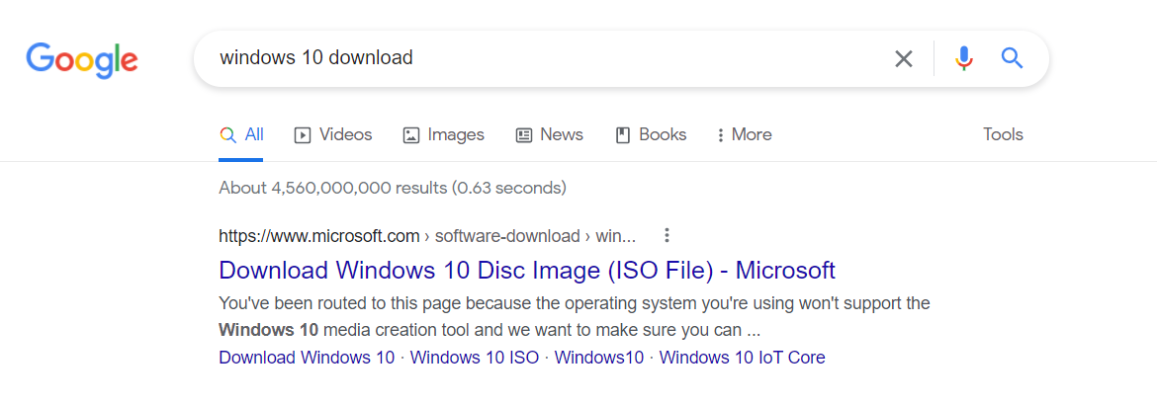

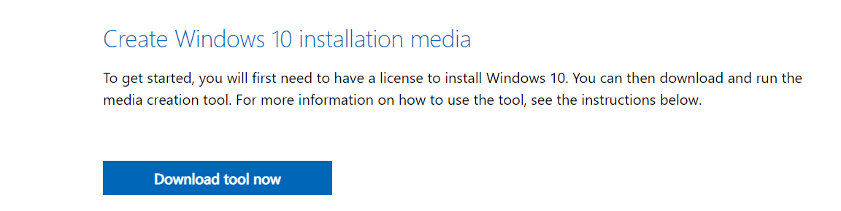



2ND RUN WINDOW DOWNLOADING TOOL

Now run the installation tool and accept the agreement and download an ISO file of windows 10 for another PC.

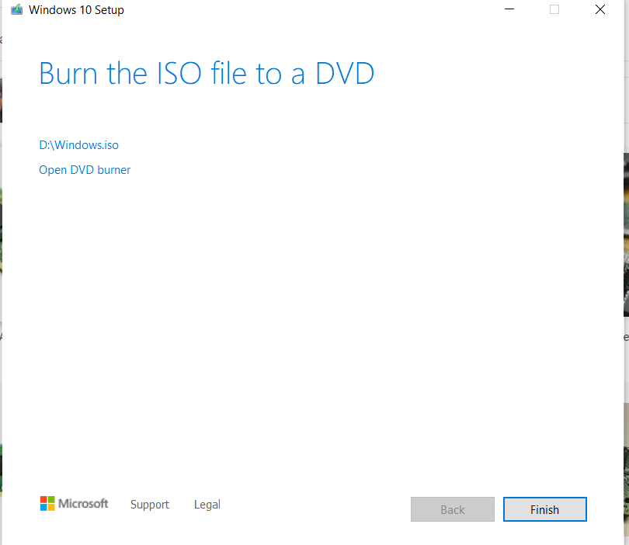

BOOTABLE USB

A bootable flash drive will allow you to boot the computer from the file system on the flash drive rather than your hard drive. ... In order for us to boot to a flash drive, it must have a master boot record, volume boot record, and contain an operating system or a program that can be executed.

We will boot USB by Rufus

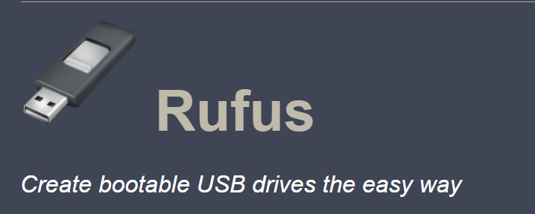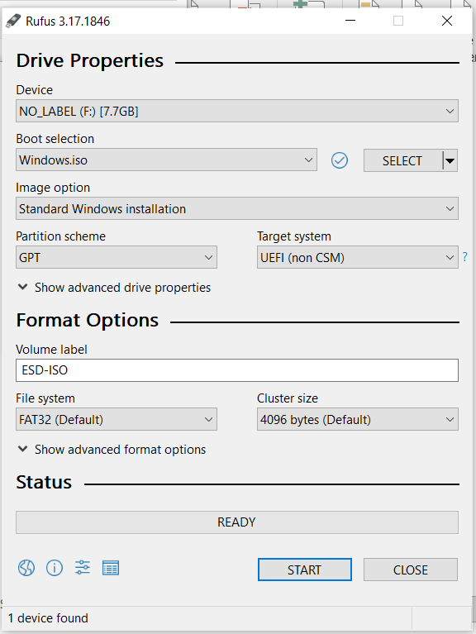

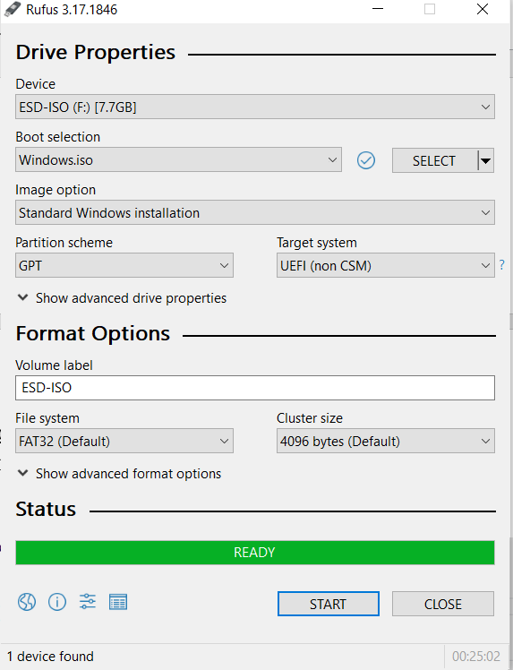

WINDOW GENUINE COPY

Genuine versions of Windows are published by Microsoft, properly licensed, and supported by Microsoft or a trusted partner. You'll need a genuine version of Windows to access the optional updates and downloads that help you get the most from your PC.

WINDOW INSTALLATION PROCESS

STEP # 01

Search window 10 in google and download window tool

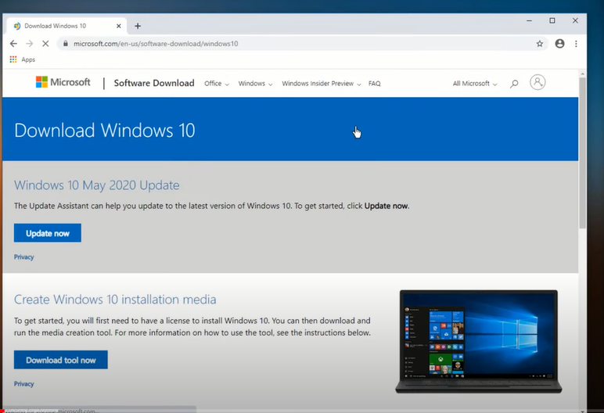

STEP # 02

*Create window media and open window tool*

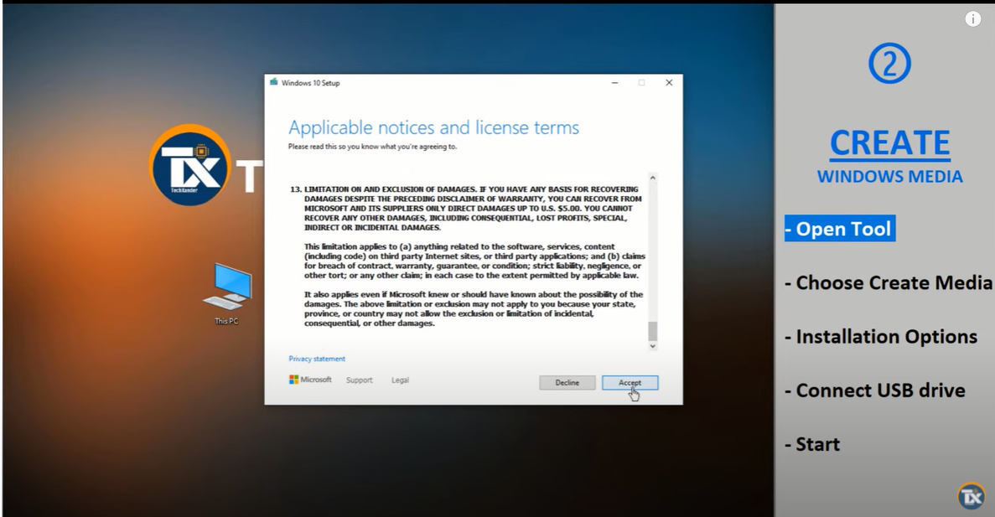

Create window media file from USB drive or ISO file to get ready for installation

STEP # 03

Connect USB to your computer where you are going to install your window.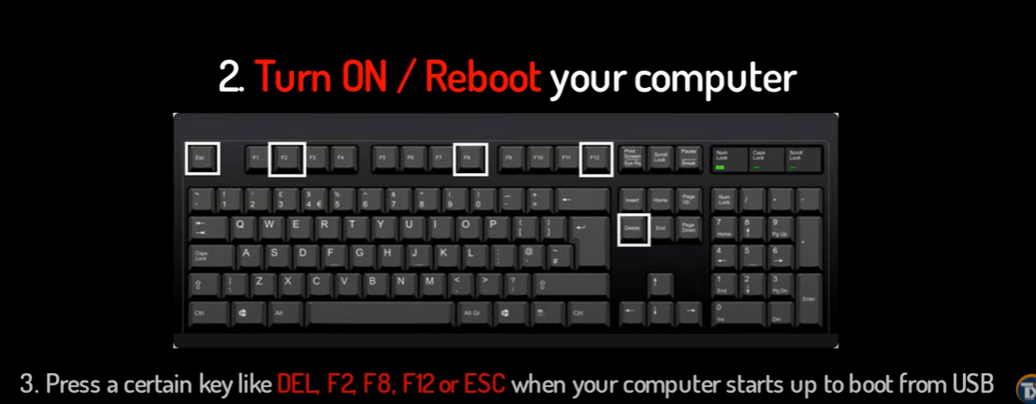STEP # 04

Now setup your initial step and product key and press the installation and start your window installation.

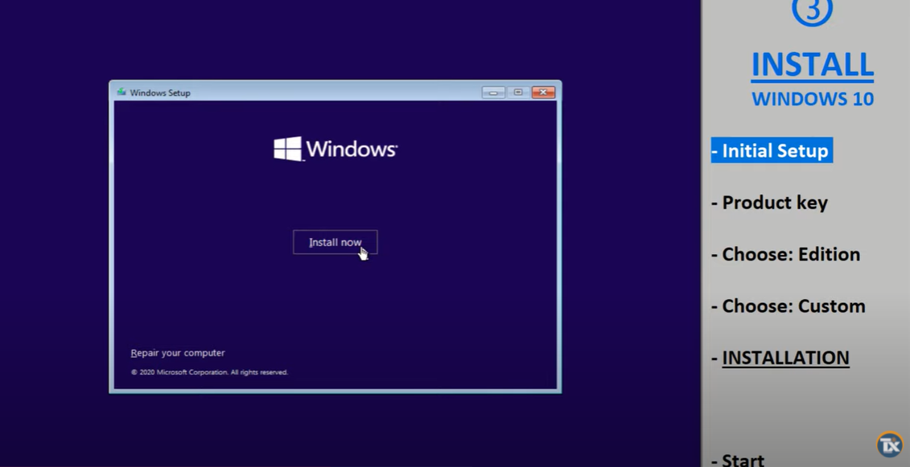

STEP # 05

After installation set up your with your privacy to set up your account this is all about installation of window 10.

